**Appendix 4**. Demonstration of the assignment of random polygon patches in space, as compared with the cities used in the analysis.

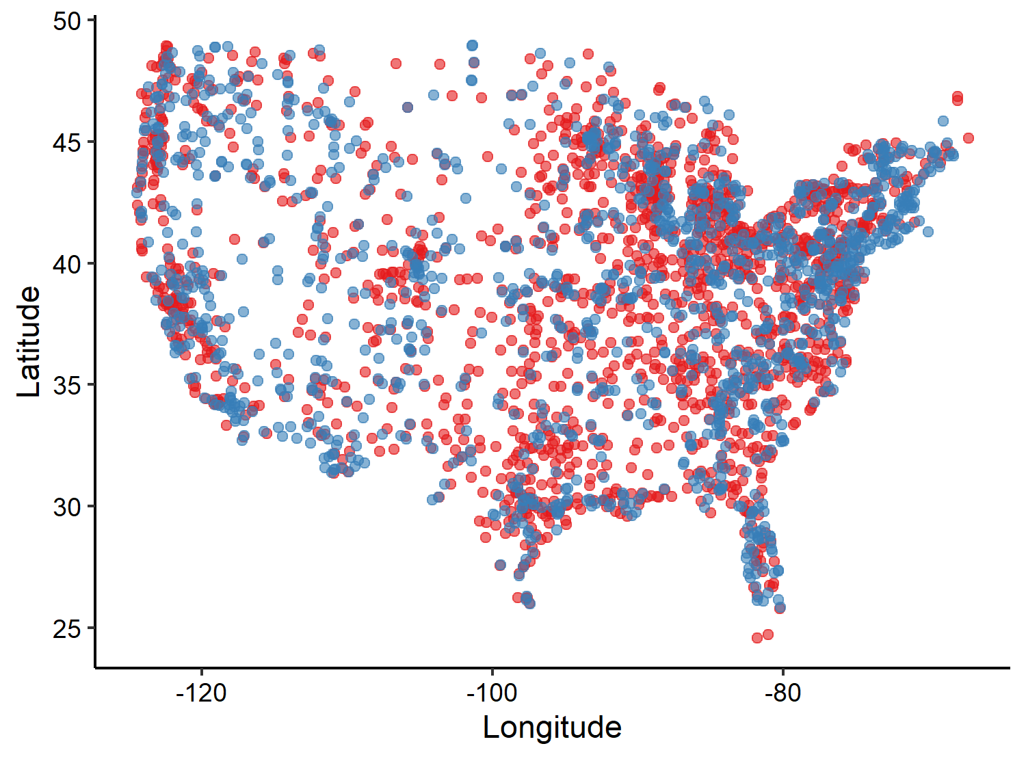

**Figure A1**. The locations of cities (green point) and randomly assigned polygon patches (yellow points) used in our analysis to compare species-area relationships between cities and random polygon patches.